HMCXZW-300 Type
Non Partial Discharge Variable Frequency Power Serial Connected Resonance Test System

Operation Manual
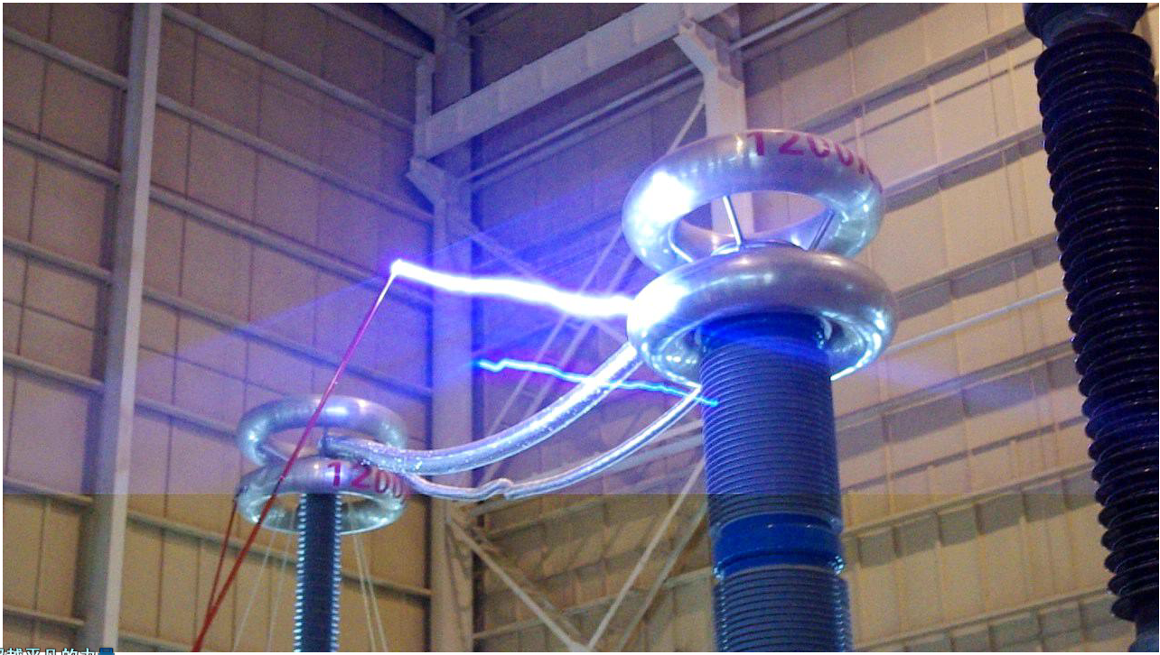

Content

1. Performance and application 1
1.1 Application 1
1.2 Main features 1
2. System Application instruction 1
2.1 Preparations 1
2.2. Test connection 2
3. Main technical index 2
3.1 Ambient conditions 2
3.2 Performance parameters of the power cubicle 3
3.3 Performance parameters of the HV box 3
4. Operation modes of control box 4
4.1 Start-up and communication 4
4.2 Test operation 6
4.3 Explanation of prompts 9
4.4 Explanations of fault alarm 10
4.5 Save and query of test data 12
4.6 Check of HV measured data 12
4.7 Single and three phase work mode 12
4.8 Parallel connected operation mode 12
4.9 Automatic Maintenance features 13
5. Precautions 14
6. Daily maintenance 15
7. After-sale services commitment 15

The process of test operation …………………………………………………………...16

1. Performance and application

1.1 Application
The HMCXZW-300 Non Partial Discharge Variable Frequency Power Serial Connected Resonance Test System is composed of non partial discharge variable frequency power, step-up transformer, compensation reactor and capacitive voltage divider. The transformer partial discharges, induced withstand voltage test system performs the test in the way of induction. It applied voltage to the LV side of the test object and produced the large excitation current via changing the frequency of the test circuit with the application of parallel resonance principle. The Serial Connected Resonance Test System is made up of variable frequency power source, excitation transformer, HV reactor and capacitive voltage divider. The capacitor and reactor of test object formed a serial resonance connection. The voltage divider is in serial connection with the test object and used for measuring the resonance voltage and acting as the overvoltage protection signal. The frequency modulation power output is coupled to series resonance circuit via excitation transformer to provide the exciting power.
This test system does not have a problem of large starting current. The power supply with small capacity is capable of fulfilling the test equivalent to 30 to 60 times of the power supply. This greatly solved the problem of poor capacity of test power at site.

1.2 Main features
- The device is safe and reliable, which integrated all kinds of protections including overvoltage protection, overcurrent protection, discharge (breakdown) protection, protection after test power failed, zero voltage start protection, overheat protection, etc. When any one of the above protections acted, the device will block the test voltage output and switch off the power of main circuit to make sure the safety of test personnel, test object and the test system.
- The operation is easy and convenient with simple connection.
- Small in size, light in weight, flexible handling which is suitable for field use.
- It adopts microcomputer control, which has good output stability and high reliability.
- The high voltgae output sine wave distortion is less than 1%, which has no damage to the test object.

2. System Application instruction

2.1 Preparations
- Safety precautions should be made;
- Make sure the MCB in the frequency conversion cubicle is off before wiring;
- Make sure the power source of the frequency converter is sound and completed;
- Connect 3-phase AC 380V power to the input end of the FM cubicle;
- Check whether the earthing line is fixed and firm;
- Switch on the parallel resonance testing system according the P1, and switch off the connection line among the tested devices. The tested device can be switched on after the success of the no-load test;
- The ratio of the step-up transformer is decided by the testing conditions and the value of Q in the loop.

2.2. Test connection
As shown in the wiring schematic diagram P1 below, the power supply cable is connected to the input terminal of variable frequency cubicle. It is a three phase AC 380V input with frequency of 50～60Hz with a clear indication on the cubicle. The three phase inputs do no need a phase sequence division, and they can connect to the power source randomly. When doing the test, please selected the conductor with proper section and reliably connected. There is no need for connecting a zero line in this test system.
- The variable frequency cubicle has single phase output, please selected the conductor with proper section and reliably connected.
- The earth terminal should be reliably connected, such as the enclosure of converter, enclosure of transformer, transformer HV side terminal and capacitive divider terminal, etc. should be earthed.
- HV measurement input terminal: access to the LV output terminal of capacitive divider, when the top of test voltage wave displayed are scraped, it means beyond the measuring range.
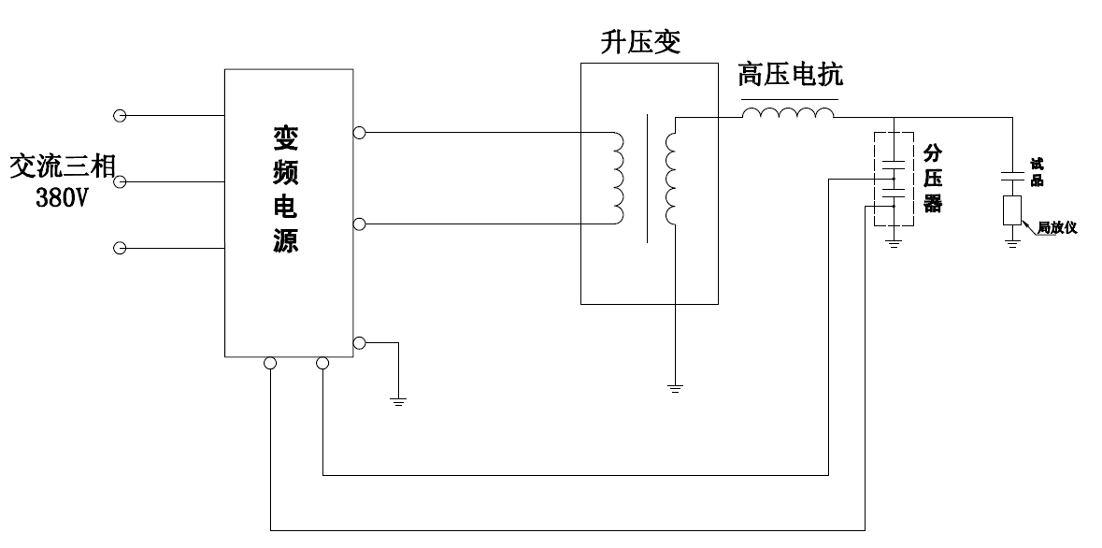
P1. Schematic diagram of test system

3. Main technical index

3.1 Ambient conditions
- Height above sea level ≤ 2000m
- Ambient temperature: —10℃～40℃
- Relative humidity ≤ 90%
- Sunlight intensity: 0.1%W/cm2
- Max. daily range of temperature <25℃
- No conductive dust
- No fire or explosion risk
- No corroding metal or insulation gas exist
- Provided with a reliable earth point
- The location gradient ≤ 5°
- Storage location: indoor
- Ambient temperature for storage: －20℃～50℃, relative humidity ≤ 90%

3.2 Performance parameters of the power cubicle
- Power input: three-phase 380V±10% 50Hz;
- Voltage output: line voltage 0～350V, continuously adjustable
- Current output: 857A (resistive)
- Power output: 300kW
- Output mode: single phase
- Adjustable range of frequency: 20～330Hz
- Adjustable accuracy of frequency: 0.1Hz
- Frequency stability: 0.01Hz
- Continuous working hours with full load: 180min
- Partial discharge capacity ≤ 10pC
- Noise level: < 85dB

3.3 Performance parameters of the HV box
- Supply voltage: AC ~ 220V
- HV measurement input voltage: AC 0～200V
- HV measurement input voltage accuracy: 1%
- HV measurement input impedance voltage: 2MΩ

4. Operation modes of control box

4.1 Start-up and communication
In the frequency conversion power source system, the operation box is applied to monitor various operating control and measured data when the power supply cubicle is in service. There are 3 kinds of displaying mode as below: normal operating control mode, data query mode and HV check mode.
(1). Start after power on and the communication connection
The splash screen will be displayed together with the start-up prompting tone after power in the operating control box. It is as shown in the below P2:
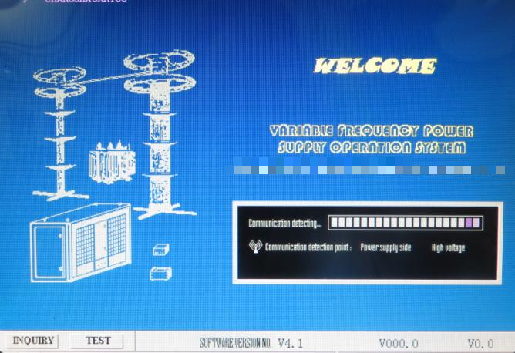
P2. Start interface
After enter the splash screen, the control box will start communicating with the power supply cubicle based on the directing position of the communication selector switch. After the communication is done and detected, the control box will start to initialize the power supply cubicle and HV measuring box, and display the progress bar and the software version information of the lower computer, and subsequently enter the normal operation mode automatically, till when the power on and the start are finished.
After the connection is completed, it should stop at this splash screen and keep detecting the communication of the power supply cubicle.
Introduction of communication modes
- The connection modes between control box and power cubicle or HV box can be selected as optical fiber or wireless mode, which can be different.
- When the optical fiber is disconnected, it’s the wireless mode; when it is connected and available for communication, it will switch to optical mode communication automatically;
- When the wireless communication mode is applied, please make sure that there is no large area of conductor barrier between two terminals. The space between heating sink on power cubicle and control box and the space between HV box front/back board and control box must be kept during the test.
- When use the wireless for communication, the control box will search the power supply cubicle and connect with it after the system is powered on; when use the fiber communication, the fiber should be connected reliably.
Notice: Before logging in the normal operation interface, press “Setup” to enter the data query mode, and “Tune” key to enter HV check mode.
(2). Introduction of Operation Interface
The normal operating control mode is divided into single-phase and 3-phase displaying mode. The main interface of the operation panel of the control box and the test (3-phase mode) is as seen in the below picture. The display interface is composed of 5 dynamically-updating displaying zones: FM power source cubicle, HV side, oscillogram, status information and operation prompt. The detailed information for these 5 zones is shown as below:
- Power supply cubicle for FM devices: display working status of the power supply cubicle and the measured value required to monitor;
- HV side: display all measured data and over voltage settings of HV side;
- Oscillogram: display the selected waveform and peak voltage at this moment in the equal amplitude;
- Status information: display the real-time operation status information of the power supply for the FM devices in the duration of test;
- Operation prompt: display the press key operation prompt and the date and time under all kinds of operation conditions.
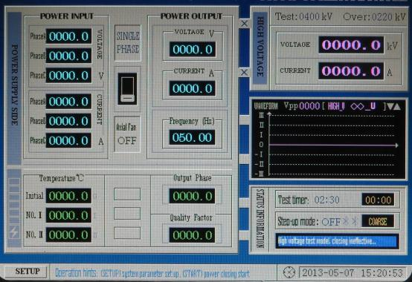
P3. Operation panel and display main interface
4.2、Test operation
(1). Test setup
Before the test, the test parameters should be set up according to the main loop connection and test requirements. Under (Only under) the opening status, it can enter the setup interface for the test parameters as shown in P4 by pressing “Setup” key. The description about all parameters is as shown:
- Test voltage: the rated voltage of HV side at test; when the voltage of the tested device exceeds the rating, it is not allowed to step up the voltage.
- Over-voltage: the over voltage setting value; when HV side exceeds this value, the power supply cubicle will trip and the output will be disconnected.
- Test timer setup, minute/second: the time setup at the test;
- High U and I transformation ratio: the ratio of the test voltage to the voltage signal that links with the HV box; HV capacitive voltage division ratio and the ratio of HV current transducer;
- Current ratio: the ratio of high voltage current transformer;
- Test transformation ratio L/H: the primary/secondary ratio of the isolation transformer in the test; it is used to work out the value of Q in the system. If the LV side is 550 and HV side is 1100, the ratio is 550/1100(1/2).
- Output mode: the single-phase and 3-phase working mode of the power supply cubicle; (if the version of the control box is V3.1, it is single-phase mode, and the 3-phase mode can be set; if the version is V1.1, it only supports the single-phase working mode)
- Auto step-up: start/stop these 2 types of setups; when it needs the auto voltage step-up, it should set it as Start;
- Range of auto tuning: search for the range in the process of auto tuning according to the test setup, and select in the scope of 20~300HZ. At setup, when the initial frequency is equal to the end frequency, they will be regulated in linkage to guarantee the initial frequency is always lower than the end frequency;
- Input current: the setting value of 3-phase input current; when it exceeds this value, the power supply cubicle will trip and stop the output;
- Output current: the max. current outputted by the power supply cubicle; when it exceeds this value, the power supply cubicle will trip and stop the output;
- Setting values of the temperature of air outlet I and II; when it exceeds this value, the power supply cubicle will trip and stop the output;
- Date and time: The setup of the time and the date for the system (save the reference time of the test data);
- Air outlet temperature: Power cabinet air vents temperature;
- Measuring switch for high voltage: start/stop the measurement of high voltage; please notice that 3 phases are interlinked at setup;
- Measuring switch for HV current: start/stop the measurement of HV current; please notice that 3 phases are interlinked at setup;

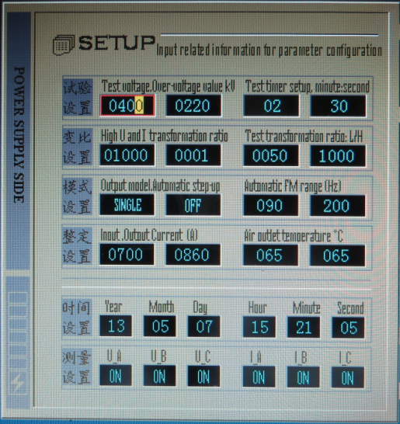
P4. Test parameter setup interface
Parameter modification steps:
  - Select the parameter that needing modifying: the parameter in the red block can be modified at present; the vertical selection is made by “▼” “▲”, and the horizontal selection is by “ ” key;
  - Select the modifying bit at present, press“ ”key to choose the current modifying bit; the revisable bit at current is in the highlight background color;
  - Change parameter: press “Step up” and “Step down” to change the parameter; the value is changed by the method of carry bit;
After the modification, re-press “Setup” to save the current displaying parameters and then exit, and meanwhile show the saving progress bar and the prompts as “Save the current test parameter and please wait……”, and then return to the main interface after saving; If you press “Stop “key, it will exit directly without saving, and thus this modification is invalid.
Notices:
- Setup for system time and date: when you press “Save” at the moment that the selection direction block stops at any position of the time bar, it will save modify the current system date and time in the meanwhile of saving the test data; therefore, please notice that when you only need set up the parameter but not modify the date and time, it should keep the selection direction block far away from the time setup bar to avoid modifying the system time and date mistakenly.
- Setup for HV measuring switch: in HV test, the HV current and voltage switches should be opened in general; only under the condition that it requires to continue the test when there has no needs to measure HV or the HV box is ruined, it should be closed (in the later case, it can adopt the multifunctional meter or other instruments to monitor and measure the high voltage after the voltage division, and then use the voltage vision ratio for the conversion so as to work out the actual test high voltage ).
(2). Switch on to start
It maintains shutdown from the moment of powering on FM power supply system to switch it on, when the close/open direction block at power supply cubicle is shown as “Open”, and the status information bar is : Off status, power output close; under this condition, press “Start” to log into: Preparing , axial fan on… ; under the condition of pre-closing, start the fan firstly, and then display “Fan start”, and carry on the pre-closing operation after 1s delay, at the instant of which the yellow indicates “Pre-close”; then, after 5s delay, it will close automatically and meanwhile show Test operating , operation effective…,and the red indicates “Close”, till this moment,, the start is finished. Under this condition, it can conduct all kinds of test operations, including manual step up/down, manual FM, auto tuning, auto step up and timing, etc.
(3). Manual test steps
- Step up to the tuning voltage: press “Step up”key to rise the output voltage of the power supply cubicle of the frequency conversion gradually. In the first step, it can adjust to 20V or around, and meanwhile please observe the high voltage should keep within 25% of the test voltage;
- Manual searching for the resonance point: when the loop is off the resonance point, the output voltage of HV side is very low. At this moment, modulate the frequency carefully around the estimated frequency. Modulate the frequency roughly at first, and observe the voltage changing trend at HV side. If the voltage of HV side rises, it means the modulation direction is correct and should continue the modulation and meanwhile observe the changes of high voltage. When the voltage of HV side drops, it means it is around the resonance point, and please switch over to “Fine tune” and modulate reversely until reaches the max. value of HV side;
- Fine tune to the best resonance point: keep the frequency of the manual searching resonance point and set the voltage of HV side as a half of test voltage. Finely modulate the frequency to increase the voltage to a higher value, when the voltage varying range is rather small. When the voltage reaches the max. value, the displayed value at “Frequency Hz” is the best resonance point;
- Raise the voltage to the test voltage for the test, or press “Timing” to start timing (the detail for timing status is described in the following pages).
(4). Auto tuning
- Set parameters: under the shutdown condition, set initial /end frequency in the P4 parameter setup interface around the resonance frequency required by the tested device or calculated before, and then press “Save” key to quit the test operation interface;
- Switch on to enter the test condition to maintain the output voltage of the power supply cubicle under 10V, and then press “Tune” key to enter the auto tuning condition and the prompt that Automatic tuning , please wait…… ; the tuning step is as below: the power supply cubicle has raised the voltage automatically (single-phase 58V and 3-phase 35V around) → auto sweep the frequency by incrementation within the set tuning frequency range (at this moment, the frequency is refreshed into the orange) → after the sweep, the displaying value in the frequency data bar is the frequency of the resonance point, and the prompt that “The frequency of the resonance point is automatically searched “will show for 3s and then it will back to the test status.
Notice: in the duration of auto tuning, if the system has found the resonance point, it should keep the frequency of the resonance point and meanwhile drop the voltage and quit; at this moment, the displaying value in the “Frequency Hz” is the frequency of the resonance point; it hasn’t found it, it will show “There has no resonance point in the loop, and please check and try again!”and then drop the voltage automatically and quit. At this moment, it should check the test main circuits, and find the reason why there has no resonance point or enlarge the tuning range to try again.
(5). Auto step up
- Set parameters: under the shutdown condition, set up the step-up mode in the P4 as auto(enable the auto step-up function) in the parameter setup interface, and set the test voltage and the correct over voltage protection value (1.1 times of the test voltage generally), and also the voltage-applying timing parameter (the auto voltage-applying timing function will be started automatically after the completion of auto step-up), and then press “Save” to exit the test operation interface;
- Switch on to log in the test status, and then press “Start” to enter the auto step-up status, when it will prompt that Automatic step-up, please wait… Now, the frequency conversion cubicle will rise the voltage automatically. When the voltage at HV side ascends to the set test voltage, it will start timing automatically. After the timing, it will drop the voltage automatically and trip automatically. The frequency conversion cubicle will stop the output.
(6). Test timing
When it shows Pressurizing timing , caution… it starts the test timing. Under this condition, the status info bar will display the count-down time in orange and trigger the voice prompt. After the completion of the timing, it will enter the auto step-down status.
There are 2 starting methods: manual and auto:
- Manual start voltage-applying timing: when rise the voltage to the required test voltage manually, press “Timing “at anytime to start timing;
- Auto start voltage-applying timing: after the completion of auto voltage step-up, it will enter the test timing status and start timing.
Notice: after the completion of timing, it will enter “Auto step-down” status to drop the voltage automatically. After the voltage descends to zero position, it will trip and quit to the stop status. At this moment, this test is finished. In the duration of timing, re-press “Timing “again to quit.
(7). Auto step-down
Automatic voltage drop, Wait turn off output … Only when the test timing is completed and there has abnormities in the auto mode, it will step down. When the output voltage descends to 5V or below, the power supply cubicle will trigger the trip automatically and return to the stop condition, and meanwhile update to “Opening”.
Notice: the test personnel should be alert in the whole process of the test, and switch off the power supply immediately at the abnormal occurrence. It should find the reason before continuing the test. If the corona makes a loud noise in the test, it can regulate the frequency by fine tuning. The corona in the test circuit will cause a great influence to Q of the whole device, and sometimes will make the voltage fail to rise to the rating. Please closely follow the standard for the step-up process, step-up speed and voltage withstand duration.

4.3、Explanation of prompts
When the system is switched on, if the following prompts (black letter against the yellow background) pop up, it indicates that the operation is beyond the permission of the program or the same operation fails to continue as a result of the abnormities in the auto control process. The prompt will display for 1s or 3s. The detailed explanations of all prompts are as below:
  - FM not allowed, please try again after voltage drop When the output voltage is more than 5V, it will limit the frequency modulation, and it will be continued after voltage drop;
  - Voltage step-up not allowed, it has reached the test voltage The test voltage rises to the setting test value;
  - Voltage step-up not allowed, it has reached the rated voltage The power cubicle output has reached to the rated output voltage of 350V;
  - Voltage step-up not allowed, please drop the voltage for the function protection the function protection of the power supply cubicle (for example: the output voltage is low and the current is large);
  - Auto voltage step-up is out of limit, please check and try again! During auto step-up process, the control box program has reached the limit but the output voltage is less than 5V;
  - HV measurement is stopped, please re-start it and try again! The HV side measuring switch is closed when it starts auto-tuning or auto voltage step-up;
  - Auto voltage step-up fails, please wait and check! The automatic step-up returned from power cubicle is failed;
  - No frequency resonance point has been found, please check and try again There is no obvious resonance point indication within the scope of set frequency range;
  - Frequency of resonance point auto searching finished It gives an indication after resonance point is found and quit the auto-tuning condition;
  - Voltage step-up not allowed, current sharing, please wait Under parallel mode, the output current >20A and then it starts auto current-sharing control. When the current difference between two cubicles is exceeding the 5% of the power ratio, it will restrict the manual boosting transiently. And when it automatic adjusted in this range, it will remove the restriction, the boosting can be continued;
  - Output current balance protection, please wait During the boosting process, the output current is automatic sharing in the single, three phase power cubicle.
Notice: when there has prompts popped up, the user should closely and correctly follow them to operate; when the abnormal occurrence happens in the duration of auto control mode, it will pop up the prompts and start dropping the voltage. After the voltage is dropped, it will trip. At this moment, please check the reason for the abnormities and then continue the test.

4.4、Explanations of fault alarm
The system will trip immediately when it has detected faults at any terminal of the power supply cubicle, HV box or the control box of the whole frequency conversion system. At this case, the fault alarm information as P5 will be indicated by the prompts of black letter against red background, and meanwhile the operation keyboard (except “Stop” and “Setup) will be locked. The process is as below: switch off the power supply cubicle directly → display the corresponding fault alarm information → lockup keyboard. The information and content of each alarm is as shown:
  - Error code: 01 … -- It has detected faults in the bridge alarm;
  - Error code: 02 … -- It has detected the output over current fault in the power supply cubicle;
  - Error code: 03 … -- It has detected HV breakdown faults or communication failure after closing in the HV box;
  - Error code: 04 … -- It has detected that the outlet temperature is more than 65°;
  - Error code: 05 … -- The power cubicle received the control box data overtime for 1s.
  - Error code: 06 … -- The DC busbar thyristor action alarms;
  - Error code: 07 … -- Any phase of the power output voltage<280V;
  - Error code: 08 … -- The extended alarm interface alarm(No.1);
  - Error code: 09 … -- The extended alarm interface alarm(No.2);
  - Error code: 10 … -- During auto boosting process, the LV>32V; HV side data< 5kV;
  - Error code: 12 … -- The control box received the HV box data overtime for 1s;
  - Error code: 14 … -- Under parallel mode, the Cubicle II promoted the signal switching failure;
  - Error code: 15 … -- The power cubicle output terminal had a short-circuit protection;
  - Error code: 16 … -- The control box received the power cubicle data overtime for 1s;
  - Error code: 17 … -- The HV measuring voltage is higher than the test over voltage setting value;
  - Error code: 18 … -- The input measuring current of the power supply cubicle is higher than the setting value;
  - Error code: 19 … -- The output measuring current of the power supply cubicle is higher than the setting value;
  - Error code: 20 … -- The temperature of the inverter is higher than the setting value;
  - Error code: 21 … -- The voltage of the input power supply is beyond 300V~450V;
  - Error code: 22 … -- The power supply cubicle fails to close normally ( it is an occasional case caused by the abnormal communication in the process of pre-closing );
  - Error code: 23 … -- The HV box received the control box data overtime for 1s;
  - Error code: 24 … -- The communication ports of cubicle I and cubicle II can not be matched when using the optical fiber mode under parallel operation;
  - Error code: 25 … -- The output polarities of cubicle I and cubicle II are inverse connected under parallel operation;
  - Error code: 32 … -- The internal auto current-sharing of single, three-phase integrated power cubicle exceeds the max. limit;
Notice: when the system alarms on the faults, all the operation keys except “Stop” and “Setup” are locked to prohibit to continue. At that moment, press “Stop” to shutdown the fan and “Setup” to enter the parameter setup interface. However, when it quits and returns to the main operation interface, it will lock the keyboard and continue to show the alarm information. Therefore, you should check and find the reason for the faults, analyze and then remove it. At last, power on the whole frequency conversion power supply system (power supply cubicle, control box and HV box).

4.5、Save and query of test data
In the working status, press “Setup/Save” key at anytime, when the status prompt bar as P6 (left) which is indicated by white letters against the blue background will show. At his moment, the test data, test setup, date and time in this page will be saved in the storage, and the record No is increased successively and automatically. It can store 19 pieces of records at most. And when it reaches the upper limit (19 pieces), the 1st piece will be covered.
The method to query the test data: when the control box is switched on and started, press “Setup” key at any moment of checking the communication of power supply cubicle to query the data. Under this condition, only “Setup”, “▼” and “▲”these 3 keys work and only support the query of saved historical test data without permission to any test operation. The status information bar of the test data storage and query is as shown in the below P6:
Switch off the control box to quit this status. Re-energize to start the control box and check that there has communication in the communication port of the power supply box before entering the normal operation main interface.

4.6、Check of HV measured data
The method to enter the test HV check mode: after the control box is switched on, press “Tune” key to enter the HV checking interface at any moment of checking the communication of power supply cubicle, and then the frequency will be set as 50.0HZ automatically and all the HV voltage and current measuring switches will be opened automatically; under this mode, there has no fault alarm function and “Start” key will be shielded; therefore, it is unable to close. This mode is only applied to check the HV measured value. The status information bar is as displayed:
High voltage test model, closing ineffective...……
Notice: when it conducts HV check, the frequency is required to be equal to the frequency of the check voltage; otherwise, the checking value will be deviated greatly.

4.7、Single and three phase work mode
Single and three phase integrated variable frequency cabinet output has single phase, three phase modes, and automatically make selection according to the wiring of output line. The output terminal of single phase mode A and B1, B2 and C connected, when open the control box and enter the operation interface it will automatically select “single phase mode” by this wiring method. The three phase mode wiring method is A, B1+B2,C, it will automatically select “three phase mode”.
The other wiring method excepted the above mentioned method are considerate as working wiring, it will warning “work mode detection error” after entering operation interface. It needs to check the output line connection, and otherwise might be auto detection mode output line failure, according to instruction and manually select the work mode of output line wiring method will function well.

4.8、Parallel connected operation mode
Parallel work mode set up: select “parallel connection” work mode under the parameter setting, save and quit, restart and connect to power source cabinet I, power source cabinet II and enter parallel connected operation mode after communication.
Parallel operation mode instruction: under parallel connection mode cabinet I and II are master-slave work mode. Cabinet II is salve, and the single is collected from master cabinet I. by adopting fiber method, the communication terminal of power source cabinet can not be reverse connected. Otherwise it will show warning message “power source cabinet communication terminal match error”, and it needs to transpose the communication terminal of cabinet I and II. It adopts wireless automatic detection, and it stays at start up interface to continuously detecting.

4.9、Automatic Maintenance features
Automatic maintenance features: this function is used for the power amplifier tube of internal power source cabinet burnout during recovering test, it will automatically recover the burnout triode, only needs to operate the single tube protection process, and it satisfies most burnout situation.
Operation method: when it burns, it shows ”Error code 1”(bridge arm failure, please switch off and check out) message, Disconnect the power the counter output load port and restart control box, at communication successful initiating, operate according to “Automatic maintenance features : Press the + key to confirm to enter” information, start up single tube protection function, press “start” to operate, until the operation completed, disconnect power and restart power source cabinet and control box, and it could operate well.
Note: The automatic maintenance process will require a couple of minutes, if it is interrupted during the process, it will need to restart up.

5. Precautions
Please read this operation manual carefully before use it. Special attention should be paid to the notices. Otherwise, the misoperation will cause damage to the device.
- The device should be operated by specialized person, and please make sure the safety during us.
- The operating power of frequency converter is fetched from the 380V AC power without insulation processing. There for the two output terminals of the converter should not be earthed directly or short-circuited. Or it will cause damage to the components.
- When it modified adjacent to the resonance point, the voltage is increased quickly and it’s not easy to control the boosting rate. Generally you can find the resonance point at low voltage condition and boost the voltage to the specified value. The “fine tuning” is recommended.
- The load capability of variable frequency cubicle should be within the range of the curves in P7 and P8 during the test. The large current load under low voltage is strictly prohibited. The upper part of the curves is the safe area. Or it will increase the internal loss and even worse lead to the damage. When it is beyond the curve, it will display“Step-up prohibited, function protection, please step-down”. Then you need to modify the ration of intermediate step-up transformer or lower the load current to continue the test.
Output phase current
100%

50%

7.3%

3*7.3%

0 48 175 350 Output phase voltage U(V)
P7. The load capacity (resistive load) curve of system at SYFP-XX test
Rated output power
100%
40%

0 10 60 Load phase angle °
P8. The load capacity curve of system at SYFP-XX test

- After the test, you should lower the voltage to zero and then open the switch;
- After the device stopped, please DO NOT contact the conductive parts of the variable frequency power immediately. Since the existing electrical charge on capacitor of power cubicle could do harm to human body;
- Before the inspection and maintenance of the device, you should make sure the electrical charge on each component is released;
- There should be a 10 sec interval between power disconnected and next closing of power.
- After the protection acted, the device is blocked. You should switch off the power and restart it.
- Do not operate under severe mistuning condition for long time.

6. Daily maintenance
- Please do regular inspection on internal connection and the screws on each contact to avoid the looseness.
- The device should be stored in the dry, clean places. The dust cover should be applied to avoid the dust coming from air channel when it is not used.
- Fixed with special straps to avoid looseness or slip during transportation.
- When the failure can not be processed, please contact the manufacturer for maintenance.
- The connector assemblies in the device are easy to damage, please use it carefully and avoid dust and other foreign materials.

7. After-sale services commitment
- We have a 24- hour response after-sale service.
- After receiving the phone call or fax for after service requirement by user, we will give a technical response service during 36 hours. If the problem needs to be settled at site, the service personnel will arrive within 48 hours. The supplier will provide the self-use equipment to user free of charge in particular cases.
- We will assign the technical personnel to the field according to user’s requirement when performing the initial test and to make sure a successful test.
- We can provide the technical training according to user’s requirement.
- We provide one year guarantee and lifelong maintenance.

- The process of test operation
I、Test preparation :
- Preparing the safety measures at test site.
- Disconnect the variable frequency power switch, open the side door of heat elimination fan machine (>100KW power source cabinet)；
- Open the power input/output cover under variable frequency cabinet, connect three phase AC 380V power source with input side.
- Check the output no-load of variable frequency power source with power, connect and open control box, the work power of high voltage measuring box, close main air switch and connect variable frequency with power, choose and start appropriate communication method (referred to communication illustration book 4.1)
- Start closure, boost voltage and start test after inspection.
II、Test operation procedure:
- According to test requirement, connect the loop of to be tested equipment and high voltage measure, pay attention to reliable ground of each ground point.
- Start the variable frequency cabinet, high voltage box and control box with power, enter into the main operation interface after communication connected properly.
- Set up the high voltage ratio, test voltage and other parameters according to test requirement, save and exit.
- Press “start” and after closure, manually search for resonance point or press “tuning” to automatically tune ( refer to illustration 4.2), if the test does not add compensating reactor, then there is no resonance point and no need to tune.
- Carry out the boost voltage operation according to test voltage；
- After boosting voltage and decrease the voltage until output close, the test operation is completed.
Please restrict follow the point of attention during test (referred to illustration 5): pay attention to the output load capability of variable frequency cabinet, select appropriated excitation gear during resonance voltage withstand test, and so on. During the test, adopt appropriate measures according to operation information, contact the technology expert if need supports. If there is abnormal situation, please do not operation.

